IP Address to outside: http://whatismyipaddress.com/
Internet Speed: http://speakeasy.net/speedtest/

Jconsole config:
http://www.gesea.de/techdocs.htm?id=67626&page=0
http://stackoverflow.com/questions/1263991/conntecting-remote-tomcat-jmx-instance-using-jconsole

////tomcat monitor ----NOT Secured------------------------
-Dcom.sun.management.jmxremote
-Dcom.sun.management.jmxremote.port=8086
-Dcom.sun.management.jmxremote.ssl=false
-Dcom.sun.management.jmxremote.authenticate=false
-Djava.rmi.server.hostname=<host ip>

//--- secured-------------------------
-Dcom.sun.management.jmxremote
-Dcom.sun.management.jmxremote.port=8086
-Dcom.sun.management.jmxremote.ssl=true
-Dcom.sun.management.jmxremote.authenticate=true
-Dcom.sun.management.jmxremote.access.file=C:/a/jmxremote.access
-Dcom.sun.management.jmxremote.password.file=C:/a/jmxremote.password
-Djava.rmi.server.hostname=<host ip>

Content of the jmxremote.password file:
# jmx remote authentication password entries
admin e3a5E
support s3cure
Content of the jmxremote.access file:
# Access control entries:
admin readwrite
support readonly
Secure the password file:
$> chmod 600 jmxremote.password
Windows see secure_file _window.pdf
To connect Jconsole:
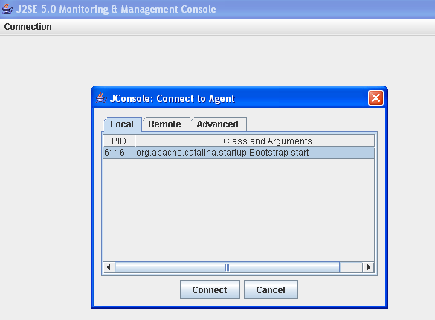

Or
<!-- Expose JMX over RMI -->
<bean id="serverConnector" class="org.springframework.jmx.support.ConnectorServerFactoryBean"
p:objectName="connector:name=rmi"
p:serviceUrl="service:jmx:rmi://localhost/jndi/rmi://localhost:1099/myconnector" />

<!-- Client connector to JMX over RMI -->
<bean id="clientConnector" class="org.springframework.jmx.support.MBeanServerConnectionFactoryBean"
p:serviceUrl="service:jmx:rmi://localhost/jndi/rmi://localhost:1099/myconnector" />

<!-- Client ServerManager proxy to JMX over RMI -->
<bean id="serverManagerProxy" class="org.springframework.jmx.access.MBeanProxyFactoryBean"
p:objectName="com.vangent.tap.app.batch.jmx:name=ScheduleManager"
p:proxyInterface="com.vangent.tap.app.batch.jmx.ScheduleManager"
p:server-ref="clientConnector" />
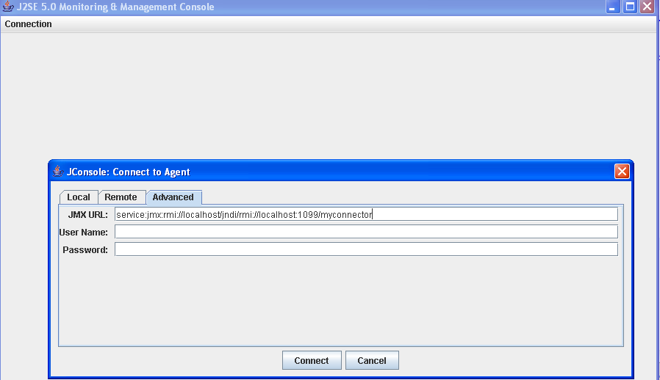

To watch session number:
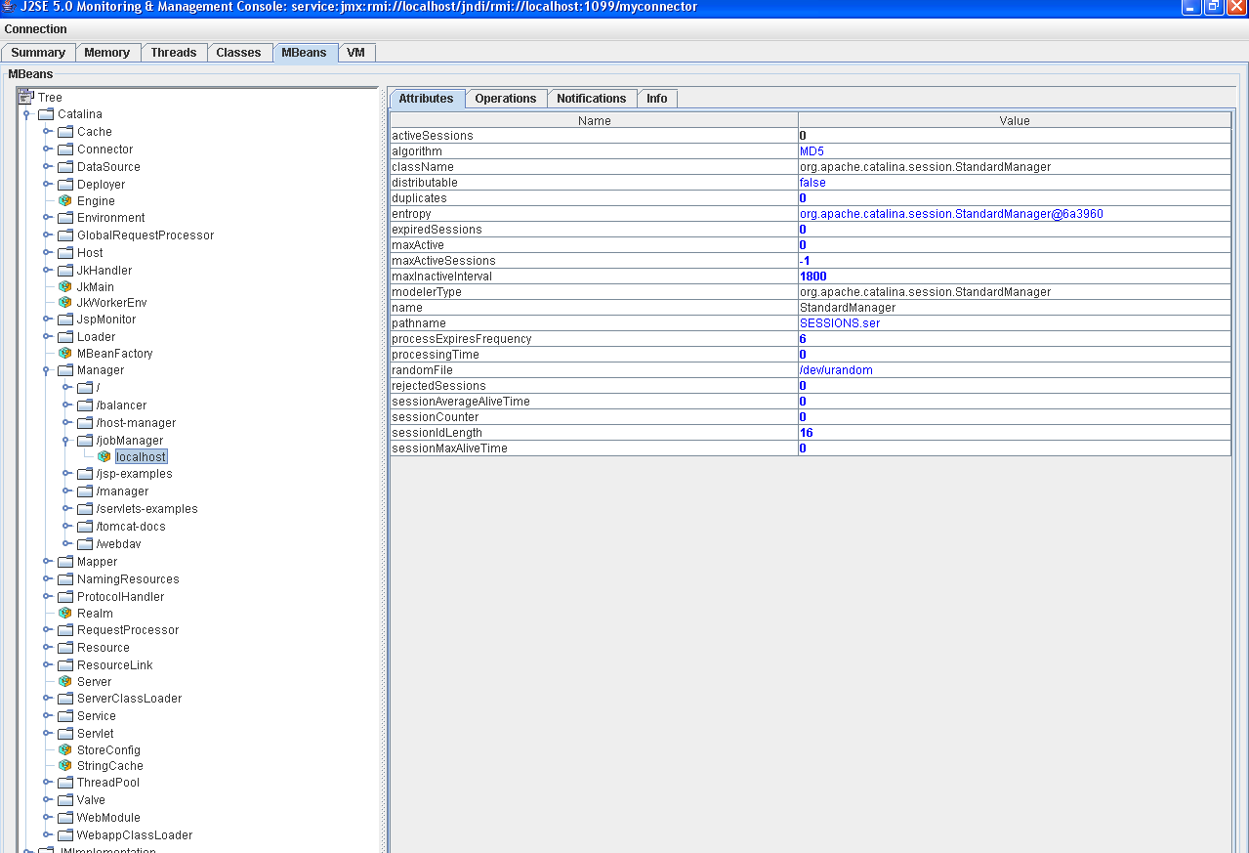

Tomcat Config:
- Config Tomcat to run Java 1.5.0.22
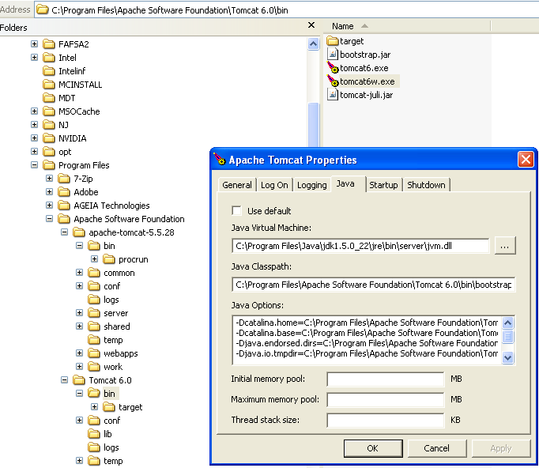

Java config:
- Java Cryptography Extension (JCE) for a key size over 40 bits to work with Java cryptography. http://java.sun.com/javase/downloads/index.jsp (The link is at the very bottom under “Other Downloads”).

PermGen issue:
-XX:+UseConcMarkSweepGC
-XX:+CMSPermGenSweepingEnabled
-XX:+CMSClassUnloadingEnabled
-XX:MaxPermSize=128m
-XX:PermSize=128m

